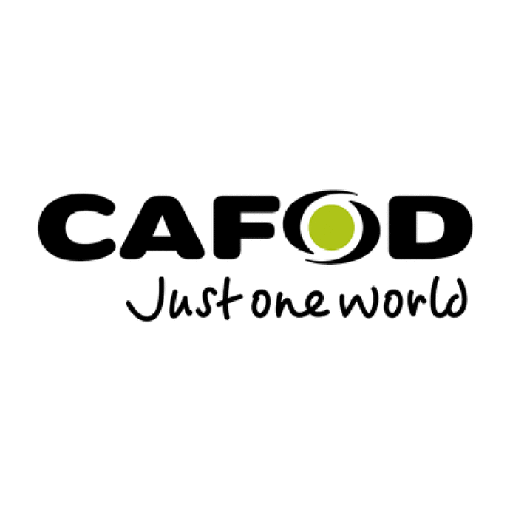
St Vincent’s Church. Live Simply Parish Pledges 2024-2025
Month | I will:
March 2024 | Reduce my use of energy: by using low energy light bulbs and turning them off when they’re not needed; turning off electrical appliances when not in use, rather than leaving on standby.
April 2024 | Recycle as efficiently as possible, including by composting; recycling batteries, pens (@St Vincent’s).
May 2024 | Reduce my environmental impact by eating less meat, cooking from scratch.
June 2024 | Do something in nature every day
July 2024 | Be part of 'Plastic Free July' by refusing single-use plastics/ packaging.
August 2024 | Use greener ways to travel- walking, cycling, bus, car sharing whenever possible.
September 2024 | I will buy Fairtrade products where possible. I will ask for a donation to a charity instead of a birthday present, Christmas presents.
October 2024 | Support Cafod Family Fast Days, including through prayer.
November 2024 | Make regular time to pray for God’s creation, the people and the planet, and commit to a time of Silence in my day- 5 minutes, 30 minutes, an hour…….
December 2024 | Where possible respond to appeals in the Bulletin to donate items to charities, e.g., St Wilfrid’s.
January 2025 | Recycle by donating to charity shops, using recycling banks. Where possible, I will upcycle my furniture and give old sofas, chairs, and tables a new look instead of replacing them.
February 2025 | Use Lent to find out more about climate issues, pray for creation, and talk about the climate crisis with others.
March 2025 | Reduce my environmental impact by supporting local food production, buying less stuff.
April 2025 | Use environmentally friendly products for washing up and cleaning.
May 2025 | Grow Salads, Vegetables, Fruit and Herbs in the garden, in pots, on windowsill, the Parish Garden!

Carbon Footprint Calculator: https://footprint.wwf.org.uk

